What is “Noise?” | When you encounter many voices, pieces of advice, and expectations coming from well meaning family members, teachers, counselors, and society.  These voices tend to drown out your own voice and individual expression and can be referred to as “noise”.
- Watch the video: |   How to tune out bad advice – and listen to your own voice!
- Log into Naviance |   Username: district ID#  Password: district password
- Click Careers > Explore Roadtrip Nation Videos |   
- Click Find your road > Define Your Road. Choose one foundation and two interests to identify and watch videos of leaders. |     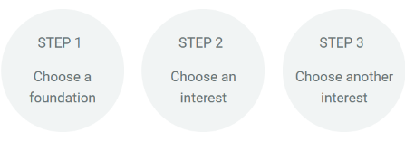
- Click Self-Discovery > Personality to take the survey helping identify your personality and tips for future success. |   
- Task Completion: | Complete Personality Survey and review your results including tips for success!

